### **Installation of VS Code**

**Steps to Download and Install Visual Studio Code on Windows 11:**

1. **Download VS Code:**
   * Visit the [Visual Studio Code website](https://code.visualstudio.com/).
   * Click the "Download for Windows" button.
2. **Install VS Code:**
   * Run the downloaded .exe file.
   * Follow the installation wizard:
     + Accept the license agreement.
     + Choose the installation location (default is recommended).
     + Select additional tasks (such as creating a desktop icon and adding to PATH).
     + Click "Install" and wait for the process to complete.
     + Click "Finish" to launch VS Code.

**Prerequisites:**

* Administrative privileges to install software.
* A stable internet connection for downloading the installer.

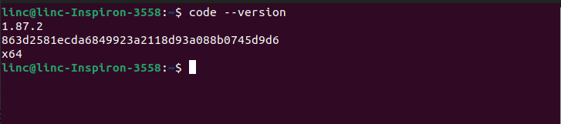

### **First-time Setup**

**Initial Configurations and Settings:**

1. **Settings:**
   * Open settings by going to File > Preferences > Settings or pressing Ctrl + ,.
   * Adjust settings such as:
     + **Font Size:** Increase or decrease the editor font size for readability.
     + **Theme:** Change the color theme to light or dark mode based on preference.
     + **Auto Save:** Enable auto-saving of files to avoid losing changes.

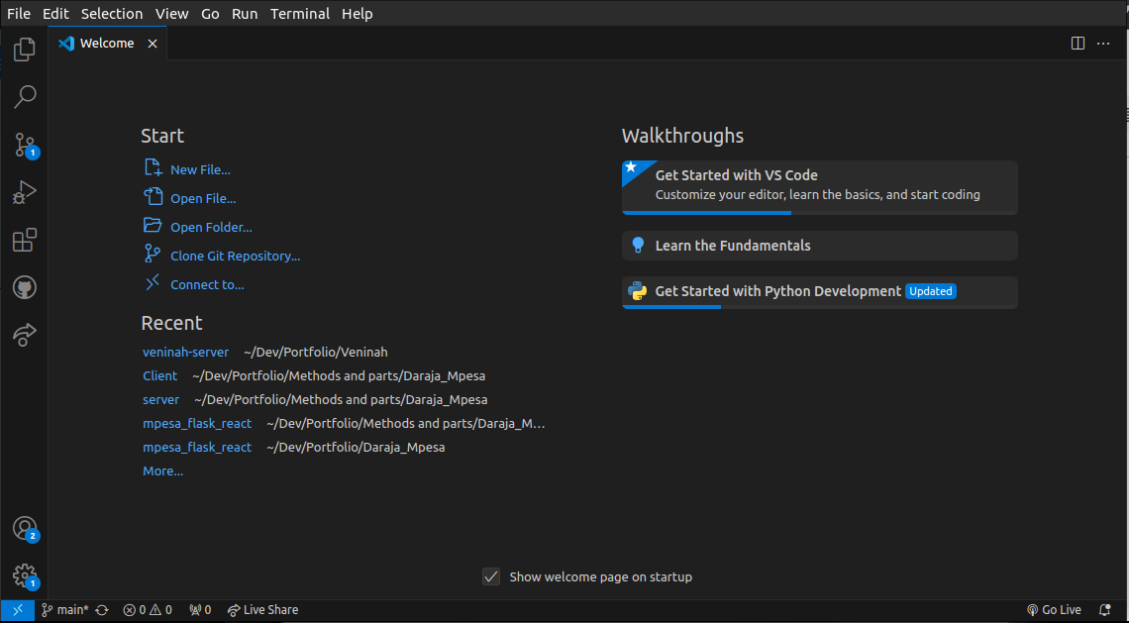

1. **Extensions:**
   * Install essential extensions such as:
     + **Prettier - Code formatter**
     + **ESLint**
     + **Python**
     + **Live Server**
     + **Live Share**
     + **Pylance**

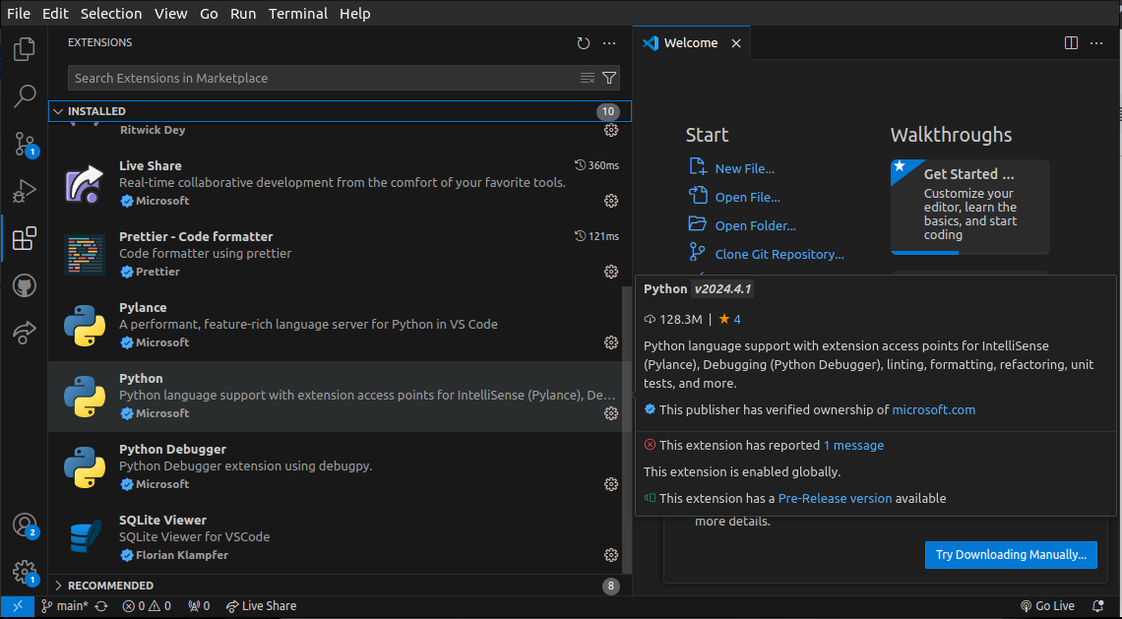

### **User Interface Overview**

**Main Components of the VS Code User Interface:**

1. **Activity Bar:**
   * Located on the left side.
   * Provides quick access to views such as Explorer, Search, Source Control, Run and Debug, and Extensions.
2. **Side Bar:**
   * Displays the selected view from the Activity Bar.
   * Example: Explorer view shows the file and folder structure of the workspace.
3. **Editor Group:**
   * The main area where files are opened and edited.
   * Supports multiple tabs and split views for multitasking.
4. **Status Bar:**
   * Located at the bottom of the window.
   * Displays information about the current file, Git branch, line number, and language mode.

### **Command Palette**

**Description and Access:**

* The Command Palette is a powerful tool for executing commands and accessing features.
* Access it by pressing Ctrl + Shift + P or F1.
* **Examples of Common Tasks:**
  + View: Toggle Terminal: Open or close the integrated terminal.
  + Git: Clone: Clone a repository from GitHub.
  + File: Save All: Save all open files.

### **Integrated Terminal**

**Opening and Using the Integrated Terminal:**

* Open the terminal by clicking View > Terminal or pressing Ctrl + .
* **Advantages:**
  + Access the terminal within the same window, allowing for seamless integration with the editor.
  + Run commands, scripts, and manage version control without switching between windows.

### 

### **File and Folder Management**

**Creating, Opening, and Managing Files and Folders:**

1. **Creating:**
   * Right-click in the Explorer view and select New File or New Folder.
2. **Opening:**
   * Double-click files in the Explorer view to open them in the Editor Group.
3. **Managing:**
   * Use drag-and-drop in the Explorer view.
   * Rename, delete, or move files and folders using the right-click context menu.
4. **Navigating:**
   * Use Ctrl + P to quickly open files by name.
   * Use breadcrumbs (at the top of the editor) for directory navigation.

### **Settings and Preferences**

**Finding and Customizing Settings:**

* Access settings via File > Preferences > Settings or Ctrl + ,.
* **Examples:**
  + **Theme:** Search for "Color Theme" and select a preferred theme.
  + **Font Size:** Search for "Font Size" and adjust as needed.
  + **Keybindings:** Customize keybindings via File > Preferences > Keyboard Shortcuts or Ctrl + K, Ctrl + S.

### **Debugging in VS Code**

**Setting Up and Starting Debugging:**

1. **Open a file to debug.**
2. **Set a breakpoint:**
   * Click in the gutter next to the line number where you want to pause execution.
3. **Start Debugging:**
   * Click the Run and Debug icon in the Activity Bar or press F5.
4. **Key Features:**
   * **Watch:** Monitor specific variables.
   * **Call Stack:** View the call stack.
   * **Variables:** Inspect the values of variables.
   * **Breakpoints:** Manage breakpoints and control execution flow.

### 

### 

### **Using Source Control**

**Integrating Git with VS Code:**

1. **Initialize a Repository:**
   * Click the Source Control icon in the Activity Bar.
   * Click "Initialize Repository".
2. **Making Commits:**
   * Stage changes by clicking the + icon next to files.
   * Enter a commit message and click the checkmark icon.
3. **Pushing Changes to GitHub:**
   * Click the "..." menu in the Source Control view.
   * Select Push to push changes to the remote repository.